***Ecology***

**Article**

**“The cost of resource use for photosynthesis drives variation in leaf nitrogen content across a climate and resource availability gradient”**

Evan A. Perkowski1,*, Helen G. Scott1, Nicholas G. Smith1

1Department of Biological Sciences, Texas Tech University, Lubbock, TX

*Correspondence to:

2901 Main St.

Lubbock, TX 79409

[evan.a.perkowski@ttu.edu](mailto:eaperkowski@gmail.com)

**Open Research Statement**

All R scripts, data, and metadata are available at <https://doi.org/10.5281/zenodo.8387808>

(or on GitHub at: <https://github.com/eaperkowski/TXeco>).

**Keywords**

eco-evolutionary optimality, ecophysiology, least-cost theory, leaf mass per area, leaf economics spectrum, plant functional ecology, photosynthesis, trait-gradient analysis

**Abstract**

Climate and resource availability are important determinants of leaf nitrogen allocation. Photosynthetic least-cost theory provides a framework for understanding the integrative role of climate and soil resource availability on leaf nitrogen content, indicating that water and nitrogen can be used as substitutable resources to support photosynthesis. The theory posits that leaf nitrogen allocation is a function of the photosynthetic cost of acquiring and using nitrogen relative to water (*β*), which is set by soil resource availability, and the ratio of leaf intercellular to atmospheric CO2 (leaf *C*i:*C*a), which is determined by climate. While promising, no study has tested this theory using concurrently measured *β*, leaf *C*i:*C*a, *N*area, and components of *N*area (leaf mass per area, *M*area; mass-based leaf nitrogen content, *N*mass). To test the theory, we measured *β*, leaf *C*i:*C*a, *N*area, *M*area, and *N*mass in 468 individuals comprising 51 species and three plant functional groups across 23 grassland sites across Texas, USA. Sites were selected based on their position along a gradient of precipitation and soil resource availability. Supporting the theory, *N*area was negatively correlated with leaf *C*i:*C*a due to negative relationships between leaf *C*i:*C*a and both *M*area and *N*mass. However, negative relationships between leaf *C*i:*C*a and *M*area and *N*mass were only observed in C3 species. *N*area and *N*mass also increased with increasing nitrogen availability and were generally greater in nitrogen-fixing species. Leaf *C*i:*C*a showed a positive correlation with β and negative correlation with vapor pressure deficit, while β increased with increasing soil moisture and decreased with increasing soil nitrogen availability, consistent with theoretical expectations. Overall, results suggest that variance in leaf nitrogen content among C3 species across the environmental gradient could be attributed to tradeoffs between nitrogen and water use, as predicted by photosynthetic least-cost theory. However, nitrogen-water use tradeoffs could not explain the variance in leaf nitrogen content among C4 species across the environmental gradient or the generally greater leaf nitrogen content in nitrogen-fixing species.

**Introduction**

Terrestrial biosphere models are sensitive to the formulation of photosynthetic processes (Knorr & Heimann, 2001; Ziehn *et al.*, 2011; Booth *et al.*, 2012). Many terrestrial biosphere models parameterize photosynthetic capacity within plant functional groups through relationships between area-based leaf nitrogen content (*N*area) and photosynthetic capacity (Kattge *et al.*, 2009; Walker *et al.*, 2014). Models are beginning to include connected carbon-nitrogen cycles (Davies-Barnard *et al.*, 2020; Kou-Giesbrecht *et al.*, 2023), which allows photosynthetic capacity to be predicted directly through changes in *N*area and indirectly through changes in nitrogen availability (Smith *et al.*, 2014; Lawrence *et al.*, 2019). Despite these model developments, open questions remain regarding the generality of relationships between nitrogen availability and *N*area across edaphic and climatic gradients.

Empirical support for positive relationships between nitrogen availability and *N*area is abundant (Firn *et al.*, 2019; Liang *et al.*, 2020), and is a pattern attributed, in part, to the high nitrogen cost of building and maintaining Ribulose-1,5-bisphosphate carboxylase/oxygenase (“Rubisco”; Evans & Seemann, 1989; Evans & Clarke, 2019). Positive *N*area and photosynthetic capacity responses to increasing nitrogen availability have been observed both in manipulative experiments and across environmental gradients (Field & Mooney, 1986; Evans, 1989; Walker *et al.*, 2014; Li *et al.*, 2020) and are thought to be driven by nitrogen limitation, which limits primary productivity globally (LeBauer & Treseder, 2008). However, this response to nitrogen availability is not consistently observed, as recent studies note variable *N*area and photosynthetic capacity responses to nitrogen availability across nitrogen fertilization experiments (Liang *et al.*, 2020; Waring *et al.*, 2023). Furthermore, aboveground conditions that set demand to build and maintain photosynthetic enzymes (e.g., light availability, temperature, vapor pressure deficit) and species identity traits (e.g., photosynthetic pathway, nutrient acquisition strategy) may be more important for explaining variance in *N*area across environmental gradients (Adams *et al.*, 2016; Dong *et al.*, 2017, 2020, 2022; Yan *et al.*, 2023; Westerband *et al.*, 2023).

Photosynthetic least-cost theory provides a hypothesis to explain the integrated effects of edaphic and climatic factors on variance in *N*area across environmental gradients. The theory posits that plants adapt and acclimate to their environment by optimizing photosynthetic assimilation rates at the lowest conglomerate photosynthetic costs of acquiring and using nitrogen and water (Wright *et al.*, 2003). All else equal, the theory predicts that an increase in nitrogen availability should decrease the photosynthetic cost of acquiring and using nitrogen relative to water(a ratio referred to herein as *β*), resulting in optimal photosynthetic rates achieved with greater *N*area and reduced ratio of leaf intercellular to atmospheric CO2 (leaf *C*i:*C*a) (Wright *et al.*, 2003; Prentice *et al.*, 2014). Alternatively, an increase in soil moisture should decrease photosynthetic costs of water acquisition and use, increasing *β*, stomatal conductance, and leaf *C*i:*C*a, and resulting in optimal photosynthetic rates achieved with decreased *N*area (Lavergne *et al.*, 2020). Climatologically, the theory suggests that the optimal response to increased vapor pressure deficit (VPD) should be a reduction in leaf *C*i:*C*a that is counterbalanced by an increase in *N*area to support the greater photosynthetic capacity needed to maintain photosynthetic rates at reduced conductance (Grossiord *et al.*, 2020; López *et al.*, 2021).

Variance in *N*area across environmental gradients may depend on species identity traits such as nutrient acquisition strategy and photosynthetic pathway. For example, species that form associations with symbiotic nitrogen-fixing bacteria (“N-fixing species”) should have access to less finite nitrogen supply than species not capable of forming such associations (“non-fixing species”), which may result in reduced *β* in N-fixing species due to enhanced nitrogen uptake rates per unit carbon invested belowground. However, these patterns are likely context-dependent on external environmental factors such as nitrogen availability or light availability, which alters plant investment to symbiotic nitrogen fixation (Taylor & Menge, 2018; Friel & Friesen, 2019; Waring *et al.*, 2023). C4 species may exhibit reduced *β* values compared to C3 species due to CO2 concentrating mechanisms that reduce stomatal conductance and therefore photosynthetic costs of water acquisition and use (Ghannoum *et al.*, 2011). However, C4 species may alternatively exhibit increased *β* values due to the same CO2 concentrating mechanisms that enhance nitrogen use efficiency and minimize photorespiration and wasteful Rubisco use, reducing the photosynthetic cost of nitrogen acquisition and use (Schmitt & Edwards, 1981; Sage *et al.*, 1987). No study has quantified *β* in C4 species aside from the initial parameterization of *β* in a C4 optimality model (Scott & Smith, 2022), and no empirical study has assessed the impacts of *β* on variance in *N*area of C4 species across environmental gradients.

Despite growing evidence supporting patterns expected from photosynthetic least-cost theory across environmental gradients (Paillassa *et al.*, 2020; Querejeta *et al.*, 2022; Westerband *et al.*, 2023), empirical studies have been restricted to exploring theoretical expectations in C3 species. Additionally, studies have not investigated the effects of resource availability, nutrient acquisition strategy, and photosynthetic pathway using *β* as a predictor of variance in *N*area. Finally, studies have not investigated how the different components of *N*area (leaf mass per area, *M*area; mass-based leaf nitrogen content, *N*mass) influence the hypothesized response of *N*area to leaf *C*i:*C*a.

Here, we measured *β*, leaf *C*i:*C*a, *N*area, *N*mass, and *M*area in 463 individuals spanning 51 species (Appendix S1: Table S1) across 23 grassland sites in Texas, USA. Sites were spread across a diverse climatic gradient, indicated by 2006-2020 mean annual precipitation ranging from 563 to 1492 mm per year across sites (Table 1; Fig. 2). Variation in nitrogen availability and soil moisture was expected across sites due to differences in soil texture and local climate that would alter water retention and mineralization rates to plant-available nitrogen substrate. We used between-site environmental variability to test the following hypotheses (Fig. 1):

1. Nitrogen availability will decrease β due to a reduction in the costs of acquiring and using nitrogen, while soil moisture will increase β due to a reduction in the costs of acquiring and using water. C4 and N-fixing species will each exhibit decreased β.
2. Leaf *C*i:*C*a will increase with increasing β and decrease with increasing VPD. C4 and N-fixing species will each have reduced leaf *C*i:*C*a compared to C3 and non-fixing species
3. *N*area will be negatively related to leaf *C*i:*C*a, which will be due to either a negative relationship between leaf *C*i:*C*a and *N*mass, a negative relationship between leaf *C*i:*C*a and *M*area, or both. C4 species will have reduced *N*area compared to C3 species, while N-fixing species will exhibit increased *N*area compared to non-fixing species

**Materials and methods**

*Site descriptions and sampling methodology*

Leaf and soil samples were collected from 23 open canopy grassland sites free from grazing and disturbance (e.g., mowing, feral hog activity) across central and eastern Texas in summer 2020 and summer 2021 (Fig. 2). Eleven sites were visited between June and July 2020 and 15 sites (12 unique from 2020) were visited between May and June 2021. Sites were selected to maximize precipitation and edaphic variability across sites (Table 1; Fig. 2). Leaf material was randomly collected from three individuals of the five most abundant species at each site, selecting only species that were of herbaceous or graminoid life forms. Only herbaceous and graminoid species were collected to minimize the impact of woody growth forms on measured responses. All collected leaves were fully expanded with no visible herbivory or external damage and were free from shading by nearby shrubs or trees. The final dataset included leaf trait measurements collected from 463 individuals comprising 51 herbaceous or graminoid species. Soil samples were collected at random locations 0-15 cm below the soil surface from each site near the leaf collection sample locations. Soil samples were mixed by hand to create one composite soil sample per site.

*Climate data*

We accessed gridded daily temperature and precipitation estimates for the coterminous United States at a 4-km grid cell resolution between January 1, 2006, and July 31, 2021, using the Parameter-elevation Regressions on Independent Slopes Model product (‘PRISM’, PRISM Climate Group, Oregon State University, <https://prism.oregonstate.edu>, data created February 4, 2014, accessed March 24, 2022). Daily VPD and precipitation data were extracted from the grid cell containing each property's coordinates using the ‘terra’ R package (Hijmans, 2022). PRISM data were used instead of local weather station data because several sites did not have a local weather station within a 20-km radius of the site. Total precipitation and mean *VPD* were calculated for the prior 1, 2, 3, 4, 5, 6, 7, 8, 9, 10, 15, 20, 25, 30, 60, and 90 days leading up to each site visit. Temperature was not used in analyses due to the close range in mean annual temperature between sites (mean±SD: 19.8±0.9ºC; Table 1).

*Edaphic characteristics*

Soil samples were sent to the Texas A&M Soil, Water, and Forage Laboratory to quantify soil nitrate concentration (NO3-N; ppm), which was used as a proxy for inorganic nitrogen availability. Soil NO3-N was determined by extracting composite soil samples in 1 M KCl, measuring the absorbance of extracts at 520 nm using the end product of a NO3-N to NO2-N cadmium reduction reaction (Keeney & Nelson, 1983; Kachurina *et al.*, 2000). Soil texture (% sand, % silt, % clay) was estimated using the simple jar method.

Soil moisture was estimated using the ‘Simple Process-Led Algorithms for Simulating Habitats’ model (‘SPLASH’; Davis et al., 2017). Daily soil moisture outputs for each site were used to calculate mean daily soil moisture for the prior 1, 2, 3, 4, 5, 6, 7, 8, 9, 10, 15, 20, 25, 30, 60, and 90 days leading up to each site visit. All soil moisture estimates were expressed as a fraction of water holding capacity to normalize values across sites, following Stocker et al. (2018). An explanation of the SPLASH model algorithm and the pedotransfer functions for estimating site water holding capacity is available in Appendix S1 (Equations S1-S7).

*Leaf trait measurements*

Images of each leaf were taken using a flatbed scanner following each site visit. Fresh leaf area was determined from each image using the 'LeafArea' R package (Katabuchi, 2015). Each leaf was dried at 65C for at least 48 hours to a constant mass, weighed, and ground to homogeneity. Leaf mass per area (*M*area; g m-2) was calculated as the ratio of dry leaf biomass to fresh leaf area. Subsamples of dried and homogenized leaf tissue were used to measure mass-based leaf nitrogen content (*N*mass; gN g-1) through elemental combustion (Costech-4010, Costech Instruments, Valencia, CA). Area-based leaf nitrogen content (*N*area; gN m-2) was calculated as the product of *N*mass and *M*area.

Subsamples of dried and homogenized leaf tissue were sent to the University of California-Davis Stable Isotope Facility to determine leaf δ13C (‰; relative to Vienna Pee Dee Belemnite international reference standard). Leaf δ13C was measured using an elemental analyzer (PDZ Europa ANCA-GSL; Sercon Ltd., Chestshire, UK) interfaced with an isotope ratio mass spectrometer (PDZ Europa 20-20 Isotope Ratio Mass Spectrometer, Sercon Ltd., Chestshire, UK). Leaf δ13C was used to estimate the ratio of intercellular (*C*i) to extracellular (*C*a) CO2 (leaf *C*i:*C*a; unitless) following the approach explained in Farquhar et al. (1989):

$Leaf \frac{C_{i}}{C_{a}}=\frac{Δ^{13}C-a}{b-a}$ (1)

where *a* is the fractionation between 12C and 13C due to diffusion in air, assumed to be 4.4‰, and *b* is the fractionation caused by Rubisco carboxylation, assumed to be 27‰ (Farquhar *et al.*, 1989). Δ13C is the relative difference between leaf δ13C (‰) and δ13C in the air (assumed to be

-8‰; Farquhar et al. 1989) and is calculated as:

(2)

For C4 species, *b* in Eqn. 1 was set to 6.3‰, derived from:

$b=c+(dφ)$ (3)

*c* was assumed to be -5.7‰ and *d* was assumed to be 30‰ (Farquhar *et al.*, 1989). φ is the bundle sheath leakiness term and was assumed as 0.4. Leaf *C*i:*C*a values less than 0.1 and greater than 0.95 were removed from the analysis (24 data points removed, ~5% of the dataset).

Photosynthetic costs of acquiring and using nitrogen relative to water (*β*) were derived using leaf *C*i:*C*a and site climate data using equations described in Prentice et al. (2014):

$β=1.6η^{*}VPD\frac{{\left(χ-\frac{Γ^{*}}{C_{a}}\right)}^{2}}{{\left(1-χ\right)}^{2}∙(K+Γ^{*})}$ (4)

Where η* is the viscosity of water relative to its viscosity at 25ºC, calculated using the mean air temperature of the seven days leading up to each site visit following equations in Huber et al. 2009). *VPD* (Pa) was set to the mean of the seven days leading up to each site visit, while *C*a represents atmospheric CO2 concentration, approximated as 420 μmol mol-1 CO2. Atmospheric CO2 concentration was converted to partial pressure (Pa) and corrected for elevation using equations described in Stocker et al. (2020) and explained in Appendix S1 (Eqn. S7). K (Pa) is the Michaelis-Menten coefficient for Rubisco affinity to CO2 and O2, and *Γ*\* is the CO2 compensation point in the absence of dark respiration. Equations for calculating Michaelis-Menten and CO2 compensation point parameters are included in Appendix S1 (Equations S8-11).

*Plant functional groups*

Plant functional group was used as the primary descriptor of species identity. Functional groups were assigned based on the photosynthetic pathway (C3, C4) and the ability to form associations with symbiotic N-fixing bacteria (N-fixer, non-fixer). The ability to form associations with symbiotic N-fixing bacteria was assigned based on whether species were in the *Fabaceae* family, as no other families known to include N-fixing species were collected. The photosynthetic pathway was determined from past literature and confirmed through leaf δ13C. No species used the CAM photosynthetic pathway. Using these functional group assignments, the dataset was divided into three distinct groups: C3 N-fixers (comprising 21 individuals from 4 species), C3 non-fixers (comprising 330 individuals from 36 species), and C4 non-fixers (comprising 117 individuals from 11 species).

*Statistical Analysis*

Analyses and plots were conducted in R version 4.1.1 (R Core Team, 2021). To address our first hypothesis and investigate the primary drivers of *β*, we constructed a linear mixed effects model where *β* was regressed against soil moisture, nitrogen availability, and functional group, in addition to all possible interactions between soil moisture, nitrogen availability, and functional group. *β* was square root transformed to normalize model residuals, and species were designated as a random intercept term. An information-theoretic model selection approach was used to determine whether 90-, 60-, 30-, 20-, 15-, 10-, 9-, 8-, 7-, 6-, 5-, 4-, 3-, 2-, or 1-day mean daily soil moisture conferred the best model fit. To do this, 16 separate linear mixed effect models were constructed where square root transformed *β* was included as the response variable, and each soil moisture timestep was separately included as a single continuous fixed effect. Species were included as a random intercept term for all models. Corrected Akaike Information Criterion (AICc) was used to select the soil moisture timescale that conferred the best model fit. This approach was used to select the timescale that conferred the best fit for *β* and should not be inferred to be the timescale in which *β* varies temporally.

To address our second hypothesis and explore the primary drivers of leaf *C*i:*C*a, a second linear mixed effect model regressed leaf *C*i:*C*a against *VPD*, soil moisture, nitrogen availability, and functional group, in addition to interactions between *VPD* and functional group and all possible interactions between soil moisture, nitrogen availability, and functional group as done for the *β* model explained above. Species were included as a random intercept term. We used an information-theoretic model selection approach to determine whether 90-, 60-, 30-, 20-, 15-, 10-, 9-, 8-, 7-, 6-, 5-, 4-, 3-, 2-, or 1-day mean daily *VPD* conferred the best model fit for leaf *C*i:*C*afollowing the same approach explained above for the soil moisture effect on *β*. Soil moisture was set to the same timescale that conferred the best fit for the *β* model explained above.

To address our third hypothesis and investigate the drivers of *N*area and components of *N*area (*N*mass and *M*area), a set of linear mixed effects models was constructed for each of *N*area, *N*mass, and *M*area. Each model regressed either *N*area, *N*mass, or *M*area against leaf *C*i:*C*a, soil moisture, nitrogen availability, and functional group, in addition to an interaction between leaf *C*i:*C*a and functional group and all possible interactions between soil moisture, nitrogen availability, and functional group as done for the *β* model explained above. Species were included in all models as a random intercept term. All response variables (*N*area, *N*mass, and *M*area) were log-transformed to normalize model residuals. Soil moisture was set to the same timescale that conferred the best fit for *β*.

In all linear mixed-effect models, we used the ‘lmer’ function in the ‘lme4’ R package (Bates *et al.*, 2015) to fit each model and the ‘Anova’ function in the ‘car’ R package (Fox & Weisberg, 2019) to calculate Type II Wald's χ2 and determine the significance level (α=0.05) of each fixed effect coefficient. We then used the ‘emmeans’ R package (Lenth, 2019) to conduct post hoc comparisons using Tukey's tests, where degrees of freedom were approximated using the Kenward-Roger approach (Kenward & Roger, 1997).

*Structural equation model*

Path analyses were constructed using piecewise structural equation modeling to examine direct and indirect pathways that contributed to variance in components of *N*area across the environmental gradient. We constructed a separate path analysis for C3 and C4 species based on strong leaf trait responses to photosynthetic pathway (Table SX-X; Figs. 3-5). For both models, the structural equation model included patterns expected from photosynthetic least-cost theory (outlined in Fig. 1) and any additional pathway that we could generate an *a priori* hypothesis for. Specifically, additional paths were added to investigate the following hypothesized direct effects: positive effects of increasing nitrogen availability on *N*mass and *M*area (Poorter *et al.*, 2009; Liang *et al.*, 2020), greater *N*mass in N-fixing species compared to non-fixing species (in the C3 model only; Adams et al., 2016; Dong et al., 2017), and covariance between *M*area and *N*mass (Wright *et al.*, 2004; Onoda *et al.*, 2017), soil moisture and nitrogen availability (Reynolds *et al.*, 2007), and *VPD* and soil moisture (Brzostek *et al.*, 2014). Model loadings and overall structural model fit parameters are further explained in Appendix S1.

**Results**

*Photosynthetic cost to acquire nitrogen relative to water* (*β*)

Ninety-day soil moisture conferred the best model fit for *β* (AICc=2781.11; Appendix S1: Table S2, Fig. S1). Increasing nitrogen availability decreased *β* (*p*=0.001; Table 2; Fig. 3a). Positive effects of increasing soil moisture on *β* (*p*<0.05; Table 2; Fig. 3b) were driven by C3 non-fixers (Tukey test of the soil moisture-*β* slope: *p*=0.001; Fig. 3b), as there was no effect of soil moisture on *β* in C3 N-fixers or C4 non-fixers (Tukey test of the soil moisture-*β* slope: *p*>0.05 in both functional groups). C4 non-fixers generally had reduced *β* compared to C3 N-fixers and C3 non-fixers (Tukey: *p*<0.001 in both cases).

*Leaf Ci:Ca*

Ninety-day mean *VPD* (*VPD*90) conferred the best model fit for leaf *C*i:*C*a (AICc=-795.37; Appendix S1: Table S2, Fig. S1). Increasing *VPD*90 decreased leaf *C*i:*C*a (*p*<0.05; Table 3; Fig. 4a). The negative effect of increasing soil moisture on leaf *C*i:*C*a (*p*<0.05; Table 3) was driven by C4 non-fixers (Tukey test of the soil moisture-leaf *C*i:*C*a slope: *p*<0.001; Fig. 4b), as there was no effect of soil moisture on leaf *C*i:*C*a in C3 N-fixers or C3 non-fixers (Tukey test of the soil moisture-leaf *C*i:*C*a slope: *p*>0.05 for both functional groups). The negative effect of increasing nitrogen availability on leaf *C*i:*C*a (*p*<0.05; Table 3) was driven by C4 non-fixers (Tukey: *p*<0.001; Fig. 4c), as there was no effect of nitrogen availability on leaf *C*i:*C*a in C3 N-fixers or C3 non-fixers (Tukey test of the soil moisture-leaf *C*i:*C*a slope: *p*>0.05 in both functional groups). C4 non-fixers generally had reduced leaf *C*i:*C*a compared to C3 N-fixers and C3 non-fixers (Tukey: *p*<0.001 in both cases).

*Leaf nitrogen content*

Increasing leaf *C*i:*C*a decreased *N*area in C3 non-fixers and C3 N-fixers (Tukey test of the leaf *C*i:*C*a-*N*area slope: *p*<0.05 for both functional groups; Fig. 5a), but this pattern was not observed in C4 non-fixers (Tukey test of the leaf *C*i:*C*a-*N*area slope in C4 non-fixers: *p*>0.05). The positive effect of increasing soil moisture on *N*area (*p*<0.05; Table 4; Fig. 5X) was driven by C4 non-fixers (Tukey test of the soil moisture-*N*area slope in C4 N-fixers: *p*=0.001), as there was no effect of soil moisture on *N*area in C3 N-fixers and C3 non-fixers (Tukey test of the soil moisture-*N*area slope in C3 N-fixers and C3 non-fixers: *p*>0.05 in both cases). C4 non-fixers generally had reduced *N*area compared to C3 N-fixers and C3 non-fixers (Tukey: *p*<0.05 in both cases), while C3 N-fixers had greater *N*area than C3 non-fixers (Tukey: *p*<0.05).

There was no relationship between leaf *C*i:*C*a and *N*mass (*p*>0.05; Table 4; Fig. 5d), nor was there an effect of soil moisture on *N*mass (*p*>0.05; Table 4). Increasing soil nitrogen availability increased *N*mass (*p*<0.001; Table 4; Fig. 5e). C4 non-fixers generally had reduced *N*mass compared to C3 N-fixers and C3 non-fixers (Tukey: *p*<0.05 in both cases).

The negative effect of increasing leaf *C*i:*C*a on *M*area (*p*<0.05; Table 4) was driven by C3 N-fixers and C3 non-fixers (Tukey test of the leaf *C*i:*C*a-*M*area slope: *p*<0.001 for both functional groups; Fig. 5g), as there was no relationship between leaf *C*i:*C*a and *M*area in C4 non-fixers (Tukey test of the leaf *C*i:*C*a-*M*area slope: *p*>0.05). Increasing soil moisture increased *M*area only in C3 legumes (Tukey test of the soil moisture-*M*area slope: *p*<0.05). Increasing nitrogen availability increased *M*area in C3 N-fixers (Tukey test of the soil nitrogen-*M*area slope: *p*<0.05) and decreased *M*area in C3 non-fixers and C4 non-fixers (Tukey test of the soil nitrogen-*M*area slope: *p*<0.05 in both cases). There were no significant pairwise differences in *M*area between functional groups despite a weak functional group effect in the model (*p*<0.05; Table 4)

*Structural equation model*

In the C3 structural equation model, soil moisture decreased with increasing vapor pressure deficit (*p*<0.001) and soil nitrogen availability decreased with increasing soil moisture (*p*<0.05). *β* increased with increasing soil moisture and decreased with increasing soil nitrogen availability (*p*<0.05 in both cases). Leaf *C*i:*C*a increased with increasing *β* (*p*<0.001) butdecreased with both increasing vapor pressure deficit (*p*<0.001) and soil moisture (*p*<0.05). *N*mass increased with increasing soil nitrogen availability (*p*<0.001) and was greater in N-fixing species (*p*<0.05) but decreased with increasing leaf *C*i:*C*a (*p*<0.05) and was negatively associated with increasing *M*area (*p*<0.001). *M*area decreased with increasing soil nitrogen availability and increasing leaf *C*i:*C*a (*p*<0.001 in both cases).

In the C4 structural equation model, soil moisture decreased with increasing vapor pressure deficit and soil nitrogen availability decreased with increasing soil moisture (*p*<0.001 in both cases). *β* increased with increasing soil moisture and decreased with increasing soil nitrogen availability (*p*<0.05 in both cases). Leaf *C*i:*C*a increased with increasing *β* (*p*<0.05) but was unrelated to vapor pressure deficit and soil moisture (*p*>0.05 in both cases). *N*mass increased with increasing soil nitrogen availability (*p*<0.05) and was negatively correlated with *M*area (*p*<0.001) but was unrelated to leaf *C*i:*C*a (*p*>0.05). *M*area decreased with increasing soil nitrogen availability (*p*<0.05) and was also unrelated to leaf *C*i:*C*a (*p*>0.05).

**Discussion**

Effects of edaphic and climatic characteristics on *N*area and components of *N*area (*N*mass and *M*area) were quantified in 468 individuals spanning an soil resource and climate gradient in grasslands across Texas, USA. Patterns supporting photosynthetic least-cost theory emerged, a result driven by a negative relationship between leaf *C*i:*C*a and *N*area mediated through direct negative effects of increasing leaf *C*i:*C*a on both *M*area and *N*mass. In further support of the theory, increasing nitrogen availability was negatively associated with *β*, resulting in an indirect positive effect of increasing nitrogen availability on *N*area mediated through a negative effect of increasing leaf *C*i:*C*a on both *M*area and *N*mass. A direct positive effect of nitrogen availability on *N*area mediated through increased *N*mass was also observed that was independent of changes in *β* and leaf *C*i:*C*a. Increasing soil moisture increased *β*, resulting in an indirect negative effect of increasing soil moisture on *N*area mediated through the negative effect of increasing leaf *C*i:*C*a on both *M*area and *N*mass. Increasing *VPD*90 decreased leaf *C*i:*C*a, indirectly increasing *N*area also through the negative effect of increasing leaf *C*i:*C*a on both *M*area and *N*mass.

Variance in leaf nitrogen content across the environmental gradient was the product of complex interactions between edaphic and climatic factors, most of which were capable of being predicted using theory. Interestingly, we observed substantial variability in *β* across the environmental gradient that was generally greater than the global mean value currently used in eco-evolutionary optimality models that adopt photosynthetic least-cost principles (e.g., the P-model; Stocker et al., 2020; Scott & Smith, 2022). Findings from this study provide important insight into understanding drivers of variability in leaf nitrogen content across environmental gradients and suggest that optimality models may improve model simulations by including an approach for predicting *β* dynamically across environmental gradients.

*Relationships between leaf Ci:Ca and Narea were driven by changes in leaf morphology*

Negative relationships between leaf *C*i:*C*a and *N*area are consistent with previous environmental gradient experiments (Dong *et al.*, 2017; Querejeta *et al.*, 2022), and support nitrogen-water use tradeoffs expected from theory (Wright *et al.*, 2003; Prentice *et al.*, 2014). Negative covariance between leaf *C*i:*C*a and *N*area was driven by negative effects of increasing leaf *C*i:*C*a on both *M*area and *N*mass, suggesting that variance in leaf nitrogen content was driven by changes in both leaf chemistry and leaf morphology across the gradient.

These results are consistent with patterns reported from previous studies indicating that variance in *N*area is driven by *M*area across environmental gradients and that part of this response is due to negative covariation between *M*area and *N*mass (Wright *et al.*, 2004; Dong *et al.*, 2017, 2022; Querejeta *et al.*, 2022; Wang *et al.*, 2023). Negative covariance between leaf *C*i:*C*a and *M*area and between *N*mass and *M*area may be indicative of tradeoffs between leaf longevity and productivity, as increased *M*area is often inferred to be the result of greater investment in cell wall tissue that helps promote greater leaf lifespan, while increased *N*mass and leaf *C*i:*C*a are each commonly associated with greater photosynthetic capacity (Onoda *et al.*, 2004, 2017). Tradeoffs between leaf longevity and productivity form a dimension of trait variation known as the leaf economics spectrum, placing individuals along a spectrum of resource-use strategies ranging from fast-growing individuals with short leaf lifespans to slow-growing individuals with long leaf lifespans (Wright *et al.*, 2004; Reich, 2014; Onoda *et al.*, 2017). These relationships support recent work suggesting that optimality principles can be used to predict tradeoffs between leaf longevity and productivity (Wang *et al.*, 2023).

*Nitrogen availability increases Narea* *through multiple pathways*

Mechanisms that explained the positive effects of increasing nitrogen availability on leaf nitrogen content were multifaceted. Structural equation results indicated that nitrogen availability can have direct positive effects on *N*area by increasing *N*mass, following previous work (Firn *et al.*, 2019; Liang *et al.*, 2020), or can alternatively have indirect positive effects on *N*area by either increased *N*mass or *M*area when mediated through reductions in the cost of acquiring nitrogen relative to water, following patterns observed in previous experiments (Perkowski *et al.*, 2021; Waring *et al.*, 2023) and those expected from theory (Paillassa *et al.*, 2020). These findings suggest that patterns expected from theory can predict some, but not all, of the variance in *N*area across nitrogen availability gradients, as direct positive effects of nitrogen availability on *N*mass are not expected from theory unless associated with reductions in ***β***. Whether positive responses of leaf nitrogen content to increasing nitrogen availability mediated through changes in ***β*** and leaf *C*i:*C*a correspond with enhanced photosynthetic capacity, as suggested in Paillassa *et al*. (2020), remains an important open question that should be addressed.

*Soil moisture effects on Narea follow theoretical expectations*

Increasing soil moisture increased *N*area, which was a pattern that was driven by a positive effect of increasing soil moisture on *N*mass and no relationship between soil moisture and *M*area. These patterns were observed despite a positive effect of soil moisture on *β*, a response likely driven by a reduction in photosynthetic costs of water acquisition (Lavergne *et al.*, 2020). While positive effects of increasing soil moisture on *β* are consistent with theoretical expectations, theory predicts that such responses should increase leaf *C*i:*C*a and decrease leaf nitrogen allocation. Structural equation model results indicated two pathways where leaf *C*i:*C*a indirectly increased and *N*area decreased in response to increasing soil moisture: (1) a pathway where increasing soil moisture increased *β*, *β* was positively related to leaf *C*i:*C*a, and leaf *C*i:*C*a was negatively related to *M*area, and (2) a pathway where increasing soil moisture exhibited strong negative covariance with nitrogen availability, leading to indirect decreases in *N*area through negative effects of increasing nitrogen availability on *β*. Interestingly, the second pathway implies that the effects of soil moisture on *N*area may have been more strongly driven by changes in nitrogen availability than directly through changes in soil moisture. Manipulative experiments that disentangle the effects of soil moisture and nitrogen availability on *β*, components of *β* (i.e., photosynthetic costs of acquiring nitrogen, photosynthetic costs of acquiring water), leaf *C*i:*C*a, and components of *N*area would help contextualize the mechanisms driving these pathways.

*Indirect effects of* ***VPD*** *on Narea are mediated through leaf Ci:Ca*

Increasing *VPD* decreased leaf *C*i:*C*a, leading to an indirect increase in *N*area through increased *M*area and *N*mass. These responses are consistent with previous work noting that increasing *VPD* decreases stomatal conductance (Oren *et al.*, 1999; Novick *et al.*, 2016; Sulman *et al.*, 2016; Grossiord *et al.*, 2020; López *et al.*, 2021) and increases *M*area (Wright *et al.*, 2005; Li *et al.*, 2019), allowing plants to minimize water loss in response to increased atmospheric water demand. Results also support findings from previous experiments across environmental gradients, where increasing *VPD* increased *N*area at reduced stomatal conductance (Dong *et al.*, 2017, 2022; Paillassa *et al.*, 2020; Westerband *et al.*, 2023). Increasing *N*area in response to increasing *VPD*90 could allow plants to maximize photosynthetic capacity under reduced stomatal conductance (Dong *et al.*, 2022). Our results could suggest that variance in *N*area across the environmental gradient was an acclimation response to aboveground climate, allowing plants to satisfy the demand to build and maintain photosynthetic enzymes and optimize photosynthetic processes by maximizing resource-use efficiency (Paillassa *et al.*, 2020; Peng *et al.*, 2021; Dong *et al.*, 2022; Westerband *et al.*, 2023). Gas exchange data collected with resource availability, ***β*, leaf *C*i:*C*a, and leaf nitrogen content** measurements would be useful to test this conjecture.

*Species identity traits contributed to variance in β, leaf Ci:Ca, and leaf nitrogen content*

N-fixing species had greater *N*area than non-fixing species, a pattern driven by greater *N*mass values in N-fixing species and similar *M*area values between N-fixing and non-fixing species. Contrasting expectations, variance in *β* and leaf *C*i:*C*a across the environmental gradient was unrelated to N-fixing ability. These results support previous studies indicating that increased *N*area in N-fixing species is not consistently correlated with stronger increases in water-use efficiency or reductions in leaf *C*i:*C*a compared to non-fixing species (Adams *et al.*, 2016; Bytnerowicz *et al.*, 2023).

C4 species had reduced *β*, leaf *C*i:*C*a, and *N*area compared to C3 species, supporting our hypotheses and some theoretical expectations. Reduced *β* in C4 non-fixers could have been due to reduced photosynthetic costs of nitrogen acquisition or increased photosynthetic costs of water acquisition (Wright *et al.*, 2003; Prentice *et al.*, 2014). These patterns may have been driven by reduced costs of nitrogen acquisition, in part because increased nitrogen-use efficiency in C4 species may reduce demand to acquire nitrogen and therefore reduce associated costs of acquiring and using nitrogen. However, this mechanism is not easily identifiable with this dataset because *β* was calculated using isotope-derived leaf *C*i:*C*a, which is itself reduced in C4 species. Future work should consider quantifying the costs of nitrogen acquisition and costs of water acquisition separately to assess which component drives changes in C4 *β* across environmental gradients.

Reduced *N*area in C4 species follows findings from previous studies (Schmitt & Edwards, 1981; Sage & Pearcy, 1987; Ghannoum *et al.*, 2011), though these patterns were not driven by negative relationships between leaf *C*i:*C*a and *N*area as expected from theory. Instead, *N*area and leaf *C*i:*C*a were each reduced in C4 species compared to both C3 functional groups. Additionally, there was no relationship between leaf *C*i:*C*a and either *N*mass or *M*area in the C4 structural equation model. Increased nitrogen-use and water-use efficiency in C4 species could reduce or eliminate the need to sacrifice inefficient nitrogen use for efficient water use to achieve optimal photosynthesis rates, which may explain why reduced *N*area in C4 species was not associated with increased leaf *C*i:*C*a.

*Implications for least-cost optimality model development*

Optimality models have been developed for C3 and C4 species using photosynthetic least-cost principles (Prentice *et al.*, 2014; Wang *et al.*, 2017; Stocker *et al.*, 2020; Scott & Smith, 2022). These models hold *β* constant using a global dataset of leaf δ13C (Wang *et al.*, 2017; Cornwell *et al.*, 2018), where C3 optimality models assume either a constant *β* of 240 (Wang *et al.*, 2017) or 146 (Stocker *et al.*, 2020), while the C4 optimality model assumes a constant *β* of 166 (Scott & Smith, 2022). In this study, *β* ranged from 67.8 to 714.5 in C3 N-fixers (mean: 297.0; median: 246.4; standard deviation: 183.8), from 15.7 to 1821.1 in C3 non-fixers (mean: 434.4; median: 339.8; standard deviation: 333.6), and from <0.1 to 362.7 in C4 non-fixers (mean: 19.6; median: 0.9; standard deviation: 59.4). The high degree of *β* variability across the environmental gradient suggests that the use of single parameterized *β* values within C3/C4 functional groups may contribute to errors in optimality model simulations.

In this study, *β* in C3 species was, on average, greater than the global mean value currently included in optimality models, suggesting that individuals in these systems had greater costs of acquiring nitrogen or reduced costs of acquiring water relative to the global mean. Interestingly, *β* in C4 species was, on average, less than the current parameterized global value, indicating that individuals had reduced costs of acquiring nitrogen or greater costs of acquiring water relative to the global mean. As mentioned above, the mechanisms driving these responses are unclear as we are unable to identify components of *β* when it is calculated using carbon isotope data. Future work should investigate mechanisms driving *β* variability across environmental gradients by quantifying the costs of nitrogen acquisition and costs of water acquisition separately.

*Conclusions*

We evaluated direct and indirect drivers of *N*area across an environmental gradient in Texas grasslands, finding that *N*area was the product of complex interactions between climate and soil resource availability. Effects of *VPD* on *N*area were mediated by negative relationships between *M*area and leaf *C*i:*C*a, while effects of nitrogen availability and soil moisture on *N*area were mediated by *β* and, in some cases, negative relationships between *M*area and leaf *C*i:*C*a. Theory could predict the impacts of photosynthetic pathway on variance in *β* and leaf *C*i:*C*a across the environmental gradient; however, leaf nitrogen content in C4 species was unrelated to leaf *C*i:*C*a, contrasting theoretical expectations. N-fixing ability had no effect on *β* and leaf *C*i:*C*a, contrasting theoretical expectations despite generally greater *N*area in N-fixing species. *β* varied substantially across the environmental gradient despite generally increasing with increasing soil moisture and decreasing with increasing nitrogen availability, suggesting that future iterations of optimality models that adopt photosynthetic least-cost principles may consider implementing frameworks where *β* is calculated dynamically. Overall, results from this environmental gradient experiment show that photosynthetic least-cost theory is capable of predicting much of the variability in leaf nitrogen content across climatic and edaphic gradients, building on previous claims that the theory may be suitable for implementation in terrestrial biosphere models.

**Conflicts of interest:** None.

**References**

**Adams MA, Turnbull TL, Sprent JI, Buchmann N**. **2016**. Legumes are different: Leaf nitrogen, photosynthesis, and water use efficiency. *Proceedings of the National Academy of Sciences of the United States of America* **113**: 4098–4103.

**Bates D, Mächler M, Bolker B, Walker S**. **2015**. Fitting linear mixed-effects models using lme4. *Journal of Statistical Software* **67**: 1–48.

**Booth BBB, Jones CD, Collins M, Totterdell IJ, Cox PM, Sitch S, Huntingford C, Betts RA, Harris GR, Lloyd J**. **2012**. High sensitivity of future global warming to land carbon cycle processes. *Environmental Research Letters* **7**: 024002.

**Brzostek ER, Dragoni D, Schmid HP, Rahman AF, Sims D, Wayson CA, Johnson DJ, Phillips RP**. **2014**. Chronic water stress reduces tree growth and the carbon sink of deciduous hardwood forests. *Global Change Biology* **20**: 2531–2539.

**Bytnerowicz TA, Funk JL, Menge DNL, Perakis SS, Wolf AA**. **2023**. Leaf nitrogen affects photosynthesis and water use efficiency similarly in nitrogen-fixing and non-fixing trees. *Journal of Ecology*: 1–15.

**Cornwell WK, Wright IJ, Turner J, Maire V, Barbour MM, Cernusak LA, Dawson TE, Ellsworth DS, Farquhar GD, Griffiths H, *et al.*** **2018**. Climate and soils together regulate photosynthetic carbon isotope discrimination within C3 plants worldwide. *Global Ecology and Biogeography* **27**: 1056–1067.

**Davies-Barnard T, Meyerholt J, Zaehle S, Friedlingstein P, Brovkin V, Fan Y, Fisher RA, Jones CD, Lee H, Peano D, *et al.*** **2020**. Nitrogen cycling in CMIP6 land surface models: progress and limitations. *Biogeosciences* **17**: 5129–5148.

**Davis TW, Prentice IC, Stocker BD, Thomas RT, Whitley RJ, Wang H, Evans BJ, Gallego-Sala A V, Sykes MT, Cramer W**. **2017**. Simple process-led algorithms for simulating habitats (SPLASH v.1.0): robust indices of radiation, evapotranspiration and plant-available moisture. *Geoscientific Model Development* **10**: 689–708.

**Dong N, Prentice IC, Evans BJ, Caddy-Retalic S, Lowe AJ, Wright IJ**. **2017**. Leaf nitrogen from first principles: field evidence for adaptive variation with climate. *Biogeosciences* **14**: 481–495.

**Dong N, Prentice IC, Wright IJ, Evans BJ, Togashi HF, Caddy-Retalic S, McInerney FA, Sparrow B, Leitch E, Lowe AJ**. **2020**. Components of leaf‐trait variation along environmental gradients. *New Phytologist* **228**: 82–94.

**Dong N, Prentice IC, Wright IJ, Wang H, Atkin OK, Bloomfield KJ, Domingues TF, Gleason SM, Maire V, Onoda Y, *et al.*** **2022**. Leaf nitrogen from the perspective of optimal plant function. *Journal of Ecology* **110**: 2585–2602.

**Evans JR**. **1989**. Photosynthesis and nitrogen relationships in leaves of C3 plants. *Oecologia* **78**: 9–19.

**Evans JR, Clarke VC**. **2019**. The nitrogen cost of photosynthesis. *Journal of Experimental Botany* **70**: 7–15.

**Evans JR, Seemann JR**. **1989**. The allocation of protein nitrogen in the photosynthetic apparatus: costs, consequences, and control. *Photosynthesis* **8**: 183–205.

**Farquhar GD, Ehleringer JR, Hubick KT**. **1989**. Carbon isotope discrimination and photosynthesis. *Annual Review of Plant Physiology and Plant Molecular Biology* **40**: 503–537.

**Field CB, Mooney HA**. **1986**. The photosynthesis-nitrogen relationship in wild plants. In: Givnish TJ, ed. On the Economy of Plant Form and Function. Cambridge: Cambridge University Press, 25–55.

**Firn J, McGree JM, Harvey E, Flores-Moreno H, Schütz M, Buckley YM, Borer ET, Seabloom EW, La Pierre KJ, MacDougall AM, *et al.*** **2019**. Leaf nutrients, not specific leaf area, are consistent indicators of elevated nutrient inputs. *Nature Ecology & Evolution* **3**: 400–406.

**Fox J, Weisberg S**. **2019**. *An R companion to applied regression*. Thousand Oaks, California: Sage.

**Friel CA, Friesen ML**. **2019**. Legumes modulate allocation to rhizobial nitrogen fixation in response to factorial light and nitrogen manipulation. *Frontiers in Plant Science* **10**: 1316.

**Ghannoum O, Evans JR, von Caemmerer S**. **2011**. Nitrogen and water use efficiency of C4 plants. In: Raghavendra AS, Sage RF, eds. C4 Photosynthesis and Related CO2 Concentrating Mechanisms. Springer, 129–146.

**Grossiord C, Buckley TN, Cernusak LA, Novick KA, Poulter B, Siegwolf RTW, Sperry JS, McDowell NG**. **2020**. Plant responses to rising vapor pressure deficit. *New Phytologist* **226**: 1550–1566.

**Hijmans RJ**. **2022**. terra: Spatial Data Analysis.

**Huber ML, Perkins RA, Laesecke A, Friend DG, Sengers J V, Assael MJ, Metaxa IN, Vogel E, Mareš R, Miyagawa K**. **2009**. New international formulation for the viscosity of H2 O. *Journal of Physical and Chemical Reference Data* **38**: 101–125.

**Kachurina OM, Zhang H, Raun WR, Krenzer EG**. **2000**. Simultaneous determination of soil aluminum, ammonium- and nitrate- nitrogen using 1 M potassium chloride. *Communications in Soil Science and Plant Analysis* **31**: 893–903.

**Katabuchi M**. **2015**. LeafArea: An R package for rapid digital analysis of leaf area. *Ecological Research* **30**: 1073–1077.

**Kattge J, Knorr W, Raddatz T, Wirth C**. **2009**. Quantifying photosynthetic capacity and its relationship to leaf nitrogen content for global-scale terrestrial biosphere models. *Global Change Biology* **15**: 976–991.

**Keeney DR, Nelson DW**. **1983**. Nitrogen—Inorganic Forms. In: Page AL, ed. Methods of Soil Analysis. Madison, WI, USA: ASA and SSSA, 643–698.

**Kenward MG, Roger JH**. **1997**. Small sample inference for fixed effects from restricted maximum likelihood. *Biometrics* **53**: 983.

**Knorr W, Heimann M**. **2001**. Uncertainties in global terrestrial biosphere modeling: 1. A comprehensive sensitivity analysis with a new photosynthesis and energy balance scheme. *Global Biogeochemical Cycles* **15**: 207–225.

**Kou-Giesbrecht S, Arora VK, Seiler C, Arneth A, Falk S, Jain AK, Joos F, Kennedy D, Knauer J, Sitch S, *et al.*** **2023**. Evaluating nitrogen cycling in terrestrial biosphere models: a disconnect between the carbon and nitrogen cycles. *Earth System Dynamics* **14**: 767–795.

**Lavergne A, Sandoval D, Hare VJ, Graven H, Prentice IC**. **2020**. Impacts of soil water stress on the acclimated stomatal limitation of photosynthesis: Insights from stable carbon isotope data. *Global Change Biology* **26**: 7158–7172.

**Lawrence DM, Fisher RA, Koven CD, Oleson KW, Swenson SC, Bonan GB, Collier N, Ghimire B, Kampenhout L, Kennedy D, *et al.*** **2019**. The Community Land Model Version 5: description of new features, benchmarking, and impact of forcing uncertainty. *Journal of Advances in Modeling Earth Systems* **11**: 4245–4287.

**LeBauer DS, Treseder K**. **2008**. Nitrogen limitation of net primary productivity in terrestrial ecosystems is globally distributed. *Ecology* **89**: 371–379.

**Lenth R**. **2019**. emmeans: estimated marginal means, aka least-squares means.

**Li Q, Wei M, Li Y, Feng G, Wang Y, Li S, Zhang D**. **2019**. Effects of soil moisture on water transport, photosynthetic carbon gain and water use efficiency in tomato are influenced by evaporative demand. *Agricultural Water Management* **226**.

**Li W, Zhang H, Huang G, Liu R, Wu H, Zhao C, McDowell NG**. **2020**. Effects of nitrogen enrichment on tree carbon allocation: A global synthesis. *Global Ecology and Biogeography* **29**: 573–589.

**Liang X, Zhang T, Lu X, Ellsworth DS, BassiriRad H, You C, Wang D, He P, Deng Q, Liu H, *et al.*** **2020**. Global response patterns of plant photosynthesis to nitrogen addition: A meta‐analysis. *Global Change Biology* **26**: 3585–3600.

**López J, Way DA, Sadok W**. **2021**. Systemic effects of rising atmospheric vapor pressure deficit on plant physiology and productivity. *Global Change Biology* **27**: 1704–1720.

**Novick KA, Ficklin DL, Stoy PC, Williams CA, Bohrer G, Oishi AC, Papuga SA, Blanken PD, Noormets A, Sulman BN, *et al.*** **2016**. The increasing importance of atmospheric demand for ecosystem water and carbon fluxes. *Nature Climate Change* **6**: 1023–1027.

**Onoda Y, Hikosaka K, Hirose T**. **2004**. Allocation of nitrogen to cell walls decreases photosynthetic nitrogen-use efficiency. *Functional Ecology* **18**: 419–425.

**Onoda Y, Wright IJ, Evans JR, Hikosaka K, Kitajima K, Niinemets Ü, Poorter H, Tosens T, Westoby M**. **2017**. Physiological and structural tradeoffs underlying the leaf economics spectrum. *New Phytologist* **214**: 1447–1463.

**Oren R, Sperry JS, Katul GG, Pataki DE, Ewers BE, Phillips N, Schäfer KVR**. **1999**. Survey and synthesis of intra- and interspecific variation in stomatal sensitivity to vapour pressure deficit. *Plant, Cell and Environment* **22**: 1515–1526.

**Paillassa J, Wright IJ, Prentice IC, Pepin S, Smith NG, Ethier G, Westerband AC, Lamarque LJ, Wang H, Cornwell WK, *et al.*** **2020**. When and where soil is important to modify the carbon and water economy of leaves. *New Phytologist* **228**: 121–135.

**Peng Y, Bloomfield KJ, Cernusak LA, Domingues TF, Prentice IC**. **2021**. Global climate and nutrient controls of photosynthetic capacity. *Communications Biology* **4**: 462.

**Perkowski EA, Waring EF, Smith NG**. **2021**. Root mass carbon costs to acquire nitrogen are determined by nitrogen and light availability in two species with different nitrogen acquisition strategies. *Journal of Experimental Botany* **72**: 5766–5776.

**Poorter H, Niinemets Ü, Poorter L, Wright IJ, Villar R**. **2009**. Causes and consequences of variation in leaf mass per area (LMA): A meta-analysis. *New Phytologist* **182**: 565–588.

**Prentice IC, Dong N, Gleason SM, Maire V, Wright IJ**. **2014**. Balancing the costs of carbon gain and water transport: testing a new theoretical framework for plant functional ecology. *Ecology Letters* **17**: 82–91.

**Querejeta JI, Prieto I, Armas C, Casanoves F, Diémé JS, Diouf M, Yossi H, Kaya B, Pugnaire FI, Rusch GM**. **2022**. Higher leaf nitrogen content is linked to tighter stomatal regulation of transpiration and more efficient water use across dryland trees. *New Phytologist* **235**: 1351–1364.

**R Core Team**. **2021**. R: A language and environment for statistical computing.

**Reich PB**. **2014**. The world-wide ‘fast-slow’ plant economics spectrum: a traits manifesto (H Cornelissen, Ed.). *Journal of Ecology* **102**: 275–301.

**Reynolds JF, Stafford Smith DM, Lambin EF, Turner BL, Mortimore M, Batterbury SPJ, Downing TE, Dowlatabadi H, Fernández RJ, Herrick JE, *et al.*** **2007**. Ecology: Global desertification: Building a science for dryland development. *Science* **316**: 847–851.

**Sage RF, Pearcy RW**. **1987**. The nitrogen use efficiency of C3 and C4 plants: I. Leaf nitrogen, growth, and biomass partitioning in *Chenopodium album* (L.) and *Amaranthus retroflexus* (L.). *Plant Physiology* **84**: 954–958.

**Sage RF, Pearcy RW, Seemann JR**. **1987**. The nitrogen use efficiency of C3 and C4 plants. *Plant Physiology* **85**: 355–359.

**Schmitt MR, Edwards GE**. **1981**. Photosynthetic capacity and nitrogen use efficiency of maize, wheat, and rice: A comparison between C3 and C4 photosynthesis. *Journal of Experimental Botany* **32**: 459–466.

**Scott HG, Smith NG**. **2022**. A model of C4 photosynthetic acclimation based on least-cost optimality theory suitable for Earth System Model incorporation. *Journal of Advances in Modeling Earth Systems* **14**: 1–16.

**Smith B, Wärlind D, Arneth A, Hickler T, Leadley P, Siltberg J, Zaehle S**. **2014**. Implications of incorporating N cycling and N limitations on primary production in an individual-based dynamic vegetation model. *Biogeosciences* **11**: 2027–2054.

**Stocker BD, Wang H, Smith NG, Harrison SP, Keenan TF, Sandoval D, Davis T, Prentice IC**. **2020**. P-model v1.0: An optimality-based light use efficiency model for simulating ecosystem gross primary production. *Geoscientific Model Development* **13**: 1545–1581.

**Stocker BD, Zscheischler J, Keenan TF, Prentice IC, Peñuelas J, Seneviratne SI**. **2018**. Quantifying soil moisture impacts on light use efficiency across biomes. *New Phytologist* **218**: 1430–1449.

**Sulman BN, Roman DT, Yi K, Wang L, Phillips RP, Novick KA**. **2016**. High atmospheric demand for water can limit forest carbon uptake and transpiration as severely as dry soil. *Geophysical Research Letters* **43**: 9686–9695.

**Taylor BN, Menge DNL**. **2018**. Light regulates tropical symbiotic nitrogen fixation more strongly than soil nitrogen. *Nature Plants* **4**: 655–661.

**Walker AP, Beckerman AP, Gu L, Kattge J, Cernusak LA, Domingues TF, Scales JC, Wohlfahrt G, Wullschleger SD, Woodward FI**. **2014**. The relationship of leaf photosynthetic traits - Vcmax and Jmax - to leaf nitrogen, leaf phosphorus, and specific leaf area: a meta-analysis and modeling study. *Ecology and Evolution* **4**: 3218–3235.

**Wang H, Prentice IC, Keenan TF, Davis TW, Wright IJ, Cornwell WK, Evans BJ, Peng C**. **2017**. Towards a universal model for carbon dioxide uptake by plants. *Nature Plants* **3**: 734–741.

**Wang H, Prentice IC, Wright IJ, Warton DI, Qiao S, Xu X, Zhou J, Kikuzawa K, Stenseth NC**. **2023**. Leaf economics fundamentals explained by optimality principles. *Science Advances* **9**: eadd566.

**Waring EF, Perkowski EA, Smith NG**. **2023**. Soil nitrogen fertilization reduces relative leaf nitrogen allocation to photosynthesis. *Journal of Experimental Botany* **74**: 5166–5180.

**Westerband AC, Wright IJ, Maire V, Paillassa J, Prentice IC, Atkin OK, Bloomfield KJ, Cernusak LA, Dong N, Gleason SM, *et al.*** **2023**. Coordination of photosynthetic traits across soil and climate gradients. *Global Change Biology* **29**: 856–873.

**Wright IJ, Reich PB, Cornelissen JHC, Falster DS, Groom PK, Hikosaka K, Lee W, Lusk CH, Niinemets Ü, Oleksyn J, *et al.*** **2005**. Modulation of leaf economic traits and trait relationships by climate. *Global Ecology and Biogeography* **14**: 411–421.

**Wright IJ, Reich PB, Westoby M**. **2003**. Least-cost input mixtures of water and nitrogen for photosynthesis. *The American Naturalist* **161**: 98–111.

**Wright IJ, Reich PB, Westoby M, Ackerly DD, Baruch Z, Bongers F, Cavender-Bares J, Chapin T, Cornelissen JHC, Diemer M, *et al.*** **2004**. The worldwide leaf economics spectrum. *Nature* **428**: 821–827.

**Yan Z, Sardans J, Peñuelas J, Detto M, Smith NG, Wang H, Guo L, Hughes AC, Guo Z, Lee CKF, *et al.*** **2023**. Global patterns and drivers of leaf photosynthetic capacity: The relative importance of environmental factors and evolutionary history. *Global Ecology and Biogeography*: 668–682.

**Ziehn T, Kattge J, Knorr W, Scholze M**. **2011**. Improving the predictability of global CO2 assimilation rates under climate change. *Geophysical Research Letters* **38**: L10404.

**Tables**

**Table 1** Site locality information, sampling year(s), 2006-2020 mean annual precipitation, 2006-2020 mean annual temperature, and water holding capacity*

|  |  |  |  |  |  |  |
| --- | --- | --- | --- | --- | --- | --- |
| **Site** | **Latitude** | **Longitude** | **Year** | **MAP** | **MAT** | **WHC** |
| Edwards_2019_17 | 29.95 | -100.36 | 2020 | 563.5 | 19.0 | 224.7 |
| Uvalde_2020_02 | 29.59 | -100.09 | 2020, 2021 | 648.5 | 19.5 | 235.2 |
| Menard_2020_01 | 30.91 | -99.57 | 2020 | 641.9 | 18.3 | 220.2 |
| Kerr_2020_03 | 30.06 | -99.34 | 2021 | 672.4 | 18.3 | 237.5 |
| Bandera_2020_03 | 29.85 | -99.30 | 2021 | 789.4 | 18.8 | 235.1 |
| Sansaba_2020_01 | 31.29 | -98.62 | 2020 | 733.0 | 18.8 | 234.3 |
| Comal_2020_21 | 29.79 | -98.43 | 2020 | 878.5 | 19.9 | 220.7 |
| Blanco_2019_16 | 29.99 | -98.43 | 2020 | 833.0 | 19.2 | 222.2 |
| Bexar_2019_13 | 29.24 | -98.43 | 2020 | 759.3 | 21.5 | 206.0 |
| Burnet_2020_14 | 30.84 | -98.34 | 2021 | 763.3 | 19.5 | 217.8 |
| Comal_2020_19 | 30.01 | -98.32 | 2021 | 845.0 | 19.3 | 220.4 |
| Hays_2021_54 | 29.96 | -98.17 | 2021 | 861.3 | 20.0 | 225.6 |
| Burnet_2020_12 | 30.82 | -98.06 | 2021 | 815.1 | 19.4 | 245.3 |
| Williamson_2019_09 | 30.71 | -97.86 | 2020 | 867.7 | 19.7 | 270.2 |
| Williamson_2019_10 | 30.54 | -97.77 | 2020 | 819.5 | 19.9 | 239.8 |
| Bell_2021_08 | 31.06 | -97.55 | 2021 | 937.3 | 19.6 | 232.3 |
| Fayette_2021_12 | 29.86 | -97.21 | 2021 | 985.7 | 20.4 | 165.6 |
| Fayette_2020_09 | 29.86 | -96.71 | 2021 | 1002.7 | 20.8 | 187.6 |
| Washington_2020_08 | 30.28 | -96.41 | 2021 | 1077.4 | 20.4 | 203.9 |
| Austin_2020_03 | 29.78 | -96.24 | 2021 | 1108.7 | 20.6 | 253.0 |
| Brazos_2020_16 | 30.93 | -96.23 | 2021 | 1078.0 | 20.1 | 202.2 |
| Brazos_2020_18 | 30.52 | -96.21 | 2020, 2021 | 1099.4 | 20.4 | 233.5 |
| Harris_2020_03 | 29.88 | -95.31 | 2020, 2021 | 1492.0 | 21.6 | 265.6 |

**\***Rows are arranged by longitude to visualize precipitation variability. Climate data were calculated using monthly PRISM data between 2006 and 2020 from the 4-km grid cell that contained each site. Key: MAP=2006-2020 mean annual precipitation (mm yr-1); MAT=2006-2020 mean annual temperature (°C); WHC=water holding capacity (mm)

**Figures**

**Figure 1**



**Figure 1** Conceptual diagram mapping hypothesized paths that explain variance in area-based leaf nitrogen content across environmental gradients. Hypothesized paths were generated following expectations from photosynthetic least-cost theory (Wright *et al.*, 2003; Prentice *et al.*, 2014; Dong *et al.*, 2017, 2020). Blue arrows indicate positive effects, while red arrows with circular anchor points indicate negative effects. Red circular-anchored arrows indicate decreased *β* in C4 species compared to C3 species and decreased *β* in N-fixing species compared to non-fixing species. Indirect paths can be inferred by multiplying the sign of each arrow across the designated path.

**Figure 2**

**Figure 2** Site locations along 2006-2020 mean annual precipitation (a) and mean annual temperature (b) gradients in Texas, USA. Precipitation and temperature data were plotted at a 4-km grid resolution using monthly PRISM data between 2006 and 2020. In both panels, addition signs (“+”) refer to sites visited in 2020, multiplication signs (“x”) to sites visited in 2021, and asterisks (“*”) to sites visited in both 2020 and 2021. The distance scale bar in (a) applies to (b).

**Figure 3**

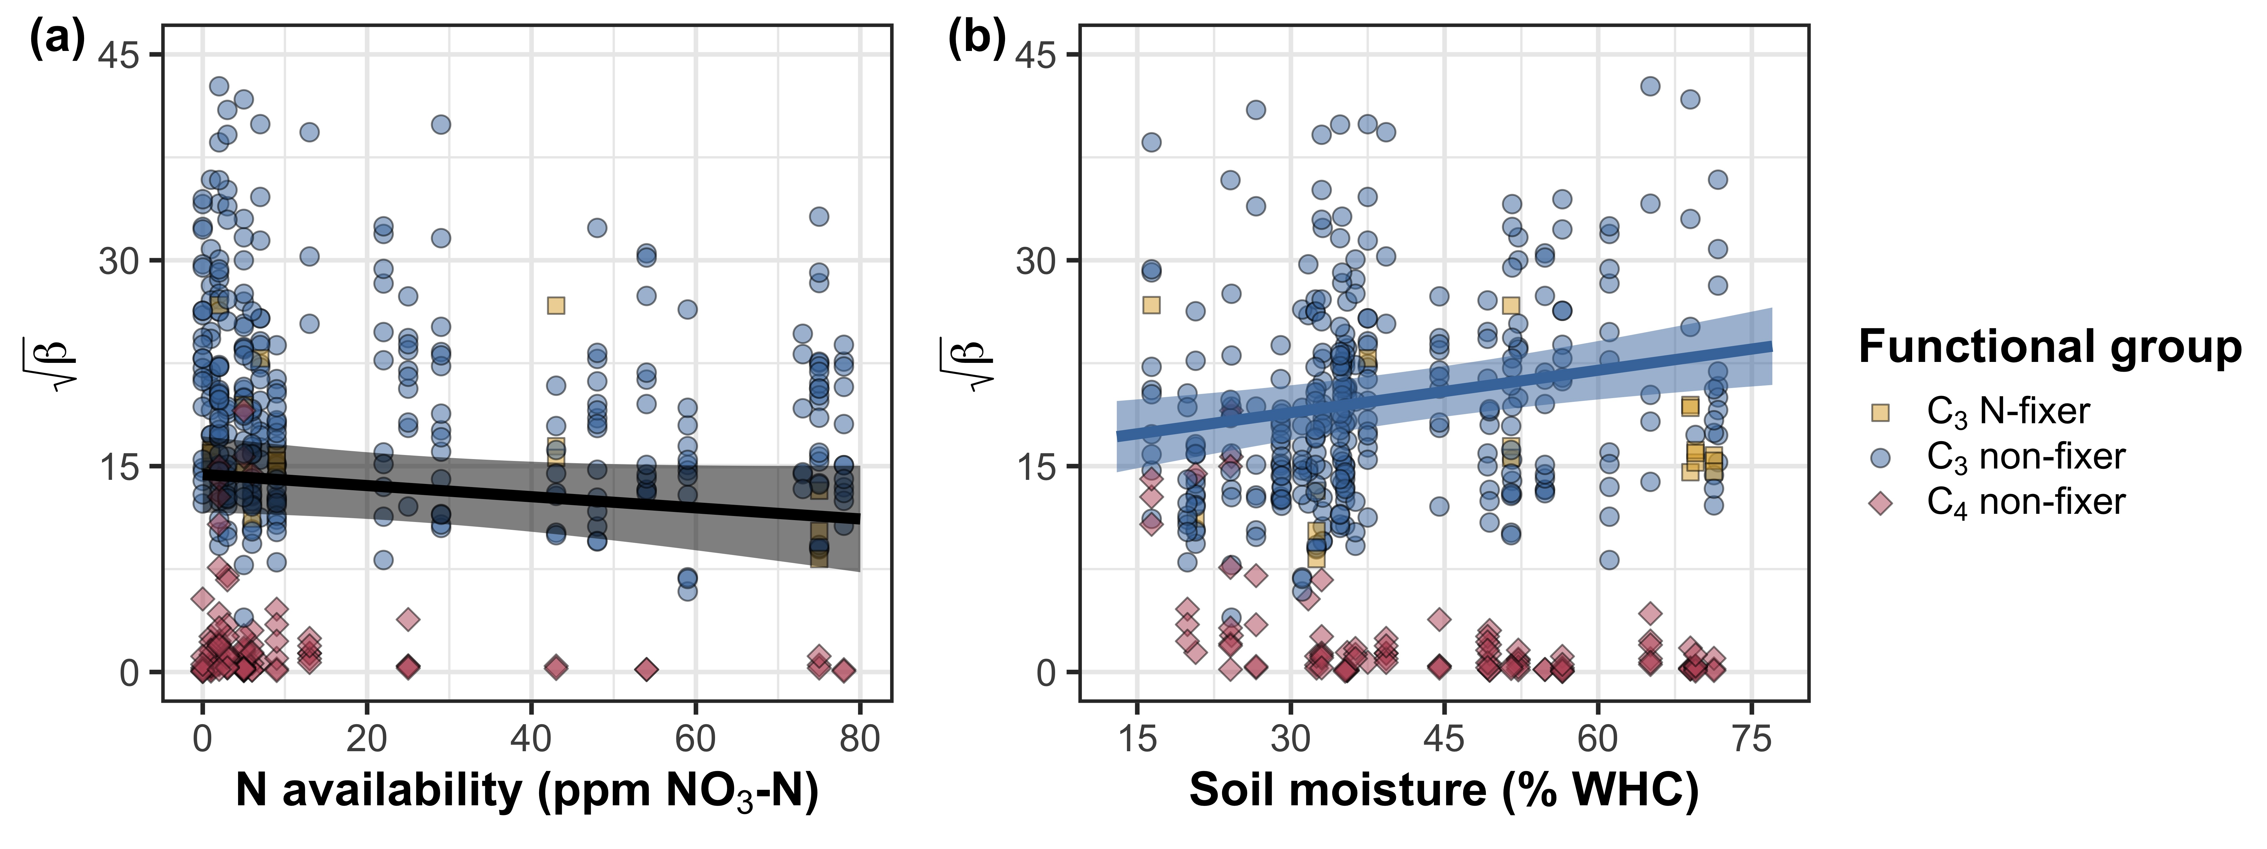

**Figure 3** Effects of nitrogen availability (a) and soil moisture (b) on the photosynthetic cost of acquiring nitrogen relative to water (*β*). *β* is included on the y-axis for both panels as square root transformed values to normalize model residuals. Yellow square-shaped points represent C3 N-fixers, blue circular-shaped points represent C3 non-fixers, and red diamond-shaped points represent C4 non-fixers. Black trendlines and 95% confidence intervals demonstrate significant relationships (*p*<0.05) averaged across functional groups, only drawn when there was no interaction between functional group and the independent variable on the x-axis. Colored trendlines and 95% confidence intervals indicate significant relationships (*p*<0.05) within functional groups, only drawn when there was an interaction between functional group and the independent variable on the x-axis. Trendlines are drawn using model predictions using the ‘emmeans’ R package (Lenth, 2019) across the range in x-axis values.

**Figure 4**

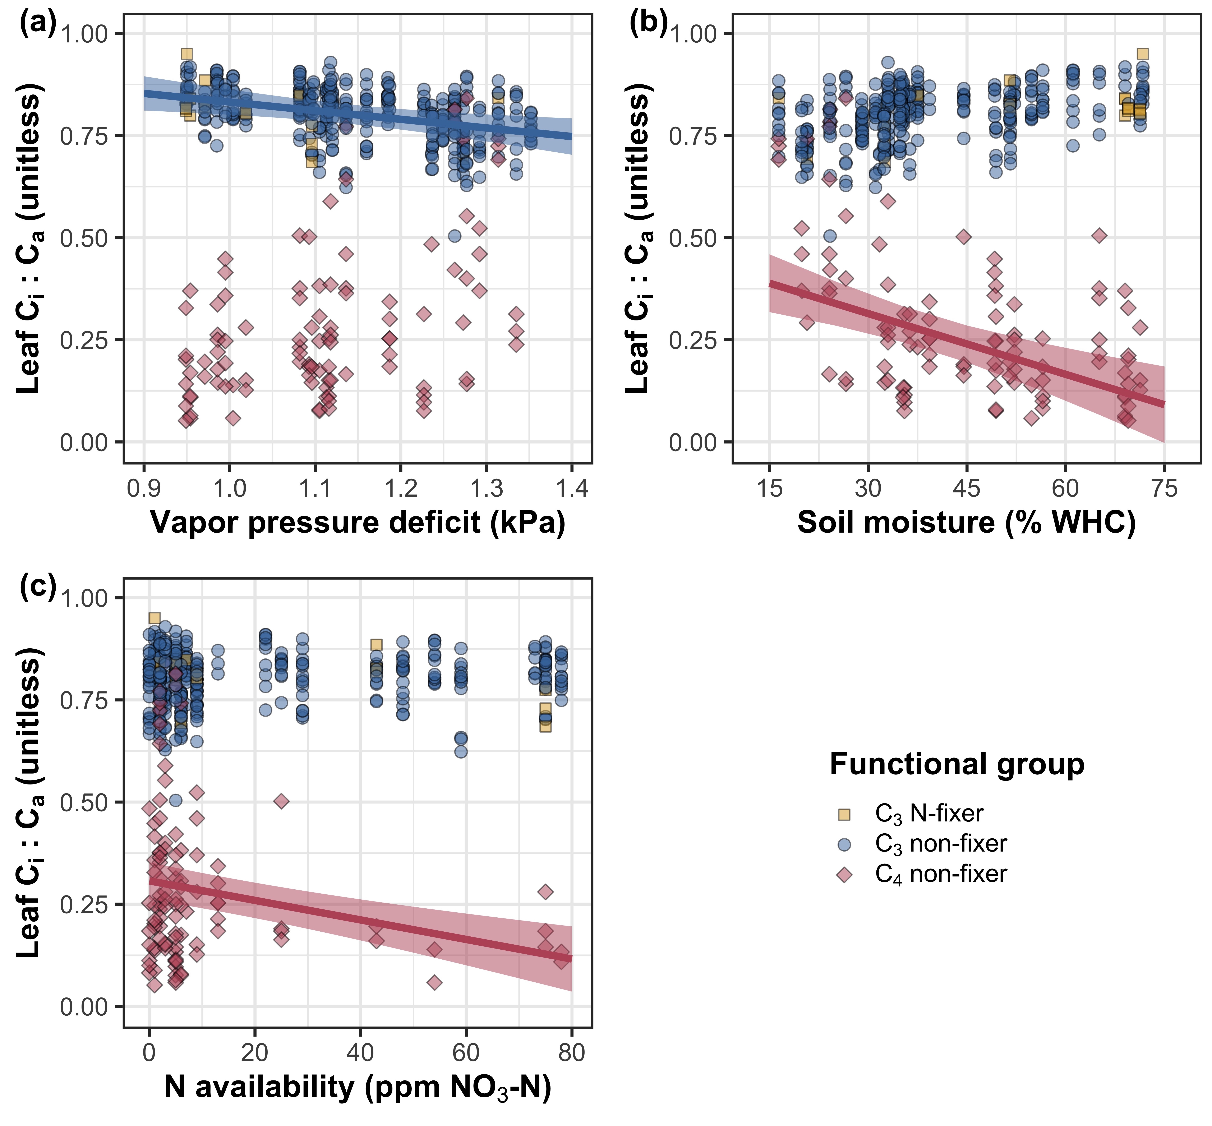

**Figure 4** Effects of vapor pressure deficit (a), soil moisture (b), and nitrogen availability (c) on leaf *C*i:*C*a. Colors and shapes are as explained in Figure 3. Colored trendlines and 95% confidence intervals demonstrate significant relationships (*p*<0.05) within functional groups. Trendlines are drawn using model predictions using the ‘emmeans’ R package (Lenth, 2019) across the range in x-axis values.

**Figure 5**



**Figure 5** Effects of leaf *C*i:*C*a, nitrogen availability, and soil moisture on area-based leaf nitrogen content (a-c), mass-based leaf nitrogen content (d-f), and leaf mass per area (g-i). Colors, shapes, and trendlines are as explained in Figure 3. All data are presented as natural log transformed values. Trendlines are drawn using model predictions using the ‘emmeans’ R package (Lenth, 2019) across the range in x-axis values.

**Figure 6**

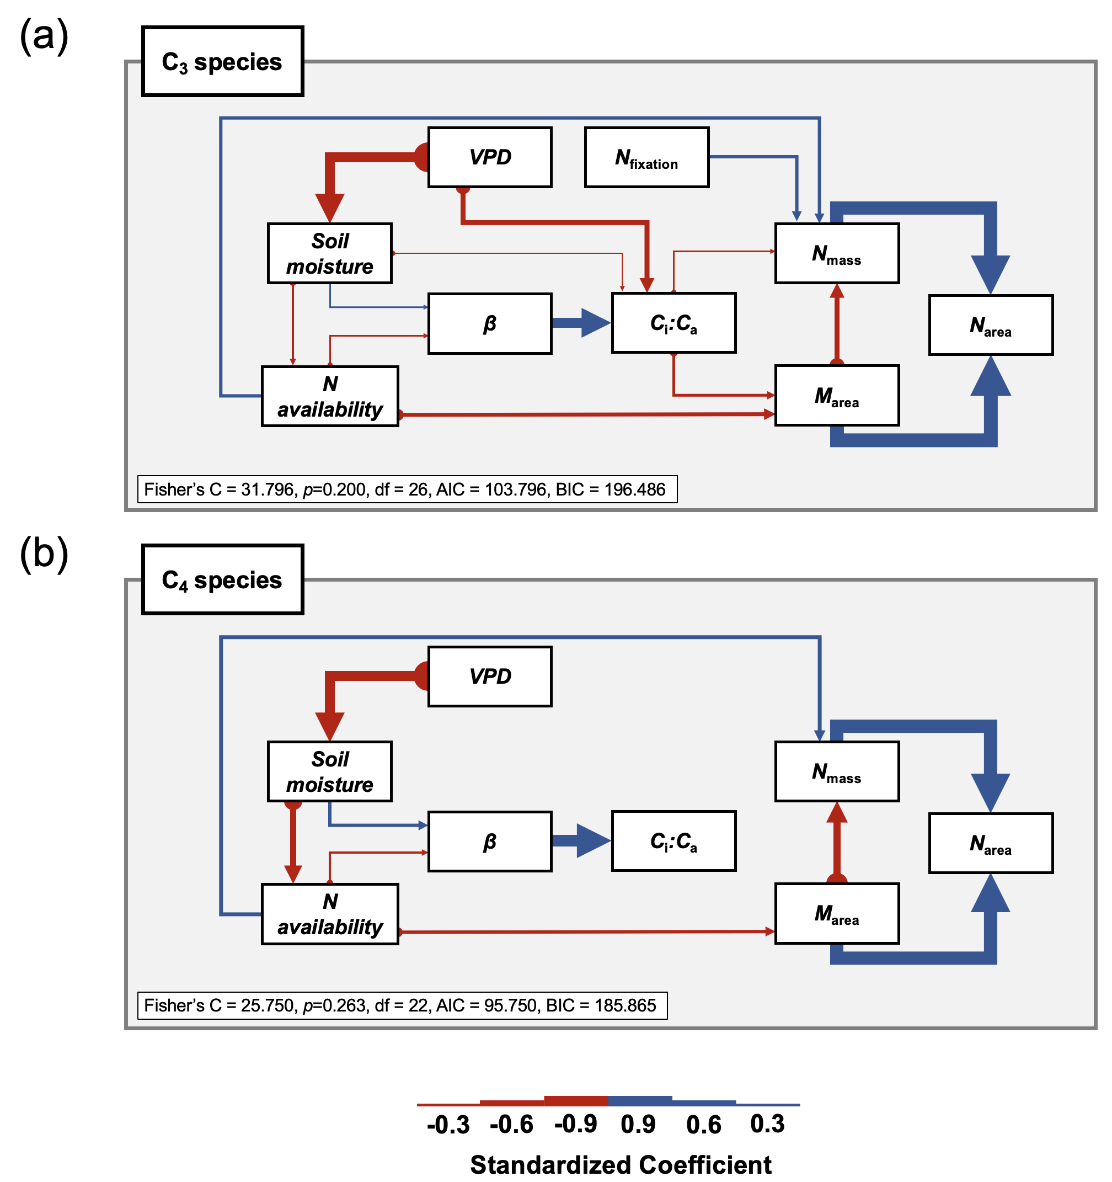

**Figure 6** Structural equation model results exploring drivers of variance in *N*area in C3 (a) and C4 (b) species. Boxes indicate edaphic and climatic variables and leaf traits. Solid arrows indicate significant relationships (*p*<0.05). Positive model coefficients are indicated through blue arrows while negative coefficients are indicated through red, circular-anchored arrows. Arrow thickness scales with the standardized model coefficient of each relationship. A positive coefficient for *N*fixation indicates greater values in N-fixing species. Model fit parameters are included in the lower left-hand corner of each panel.